Just Crack An Egg Cup DIY Version Meal Prep
Nutrition: Makes 4 meals
Calories: 220, Carbs < 8g, Fiber: 1g, Protein: 14g, Fat: 15g
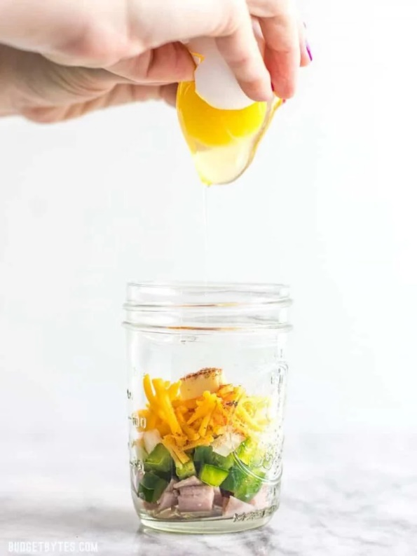
- Ingredients
  - 4 mason jars
  - 1 cup shredded uncooked hashbrowns
  - 1 cup shredded cheddar cheese
  - 4 eggs
  - 4 slices cooked bacon—or other breakfast meat
  - 1 cup chopped veggies

- Instructions
  - Open all 4 jars
  - Add ¼ cup hashbrowns to each jar
  - Add ¼ cup cheddar cheese to each
  - Add ¼ cup chopped veggies
  - Set 1 whole egg ontop of all and close jar lid
    - Refrigerate 7 days until ready to use
    - Crack egg into mason jar and cook uncovered 1 mins 30 secs

Note:
You can use 2 eggs for more protein, or use egg whites! (Bonus: Adds another 7 g protein and 80cals)

