chicken tomato and corn foil packets
YIELDS:4 SERVINGS / PREP TIME: 10 MINS
TOTAL TIME: 30 MINS
nUTRITION: Nutrition Facts
Servings 3.0| Amount per serving: calories 363
total fat 27 g, saturated fat 8G, monounsaturated fat 22G, polyunsaturated fat 2g, cholesterol 42 mg
total carbohydrate 16G, dietary fiber 3G, sugars 4G, protein 26 g
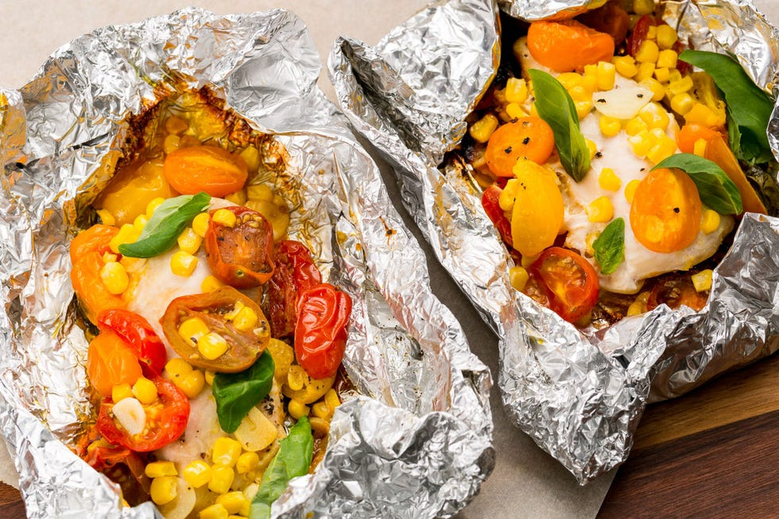
INGREDIENTS
- 3 boneless skinless chicken breasts (4 oz each)
- 2 c. grape tomatoes, halved
- 2 ears corn, kernels stripped
- 2 cloves garlic, thinly sliced
- 1/4 c. extra-virgin olive oil
- 2 tbsp. butter
- Kosher salt
- Freshly ground black pepper
- Fresh basil, for garnish

DIRECTIONS
- Heat grill to high. Cut 4 sheets of foil about 12" long. Top each piece of foil with a chicken breast, tomatoes, corn, and garlic. Drizzle each with oil and top with a pat of butter. Season with salt and pepper.
- Fold foil packets crosswise over chicken and roll top and bottom edges to seal.
- Grill until chicken is cooked through and vegetables are tender, 15 to 20 minutes.
- Serve topped with basil.
Tips:
You can swap proteins, consider doing fish or other protein sources like pork or beef, even adding beans to this !

