Strawberry Poppyseed Chicken Salad

Servings: 4 // Serving size: 3 Cups
Nutrition Facts:Amount per serving| Calories@ 230
Total Fat 8g, Saturated Fat 1g, Trans Fat 0g, Cholesterol 50mg, Sodium 160mg, Total Carbohydrate 19g, Dietary Fiber 3g, Total Sugars 8g, Added Sugars 0g, Protein 26g, Potassium 530mg, Phosphorus 270mg
* * Choices/Exchanges: 1/2 Fruit, 1/2 Carbohydrate, 3 Protein, 1/2 Fat

INGREDIENTS:
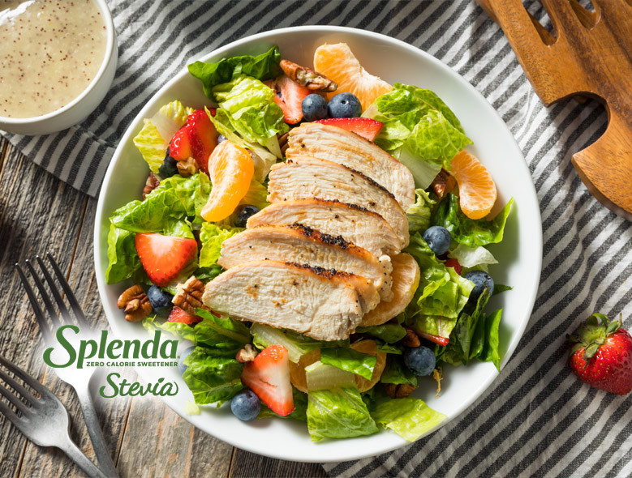
- Plain Nonfat Greek yogurt 1 cup
- Splenda Stevia Sweetener--2 tbsp
- Apple Cider Vinegar- 3 tbsp
- Ground Mustard -1/2 tsp
- Kosher Salt- 1/8 tsp
- Poppy Seeds- 2 tsp
- Spring Salad Mix- 8 cup
- Grilled Chicken Breast (8 oz)
- 1/2 cup- Fresh Strawberries (sliced)
- 1/2 cup- Fresh Blueberries
- 1/2 cup Canned, No Sugar Added Mandarin Oranges (drained)
- Toasted Pecans--1/4 cup
Directions:
- In a blender, combine all dressing ingredients (except for poppy seeds) and blend until well combined.

- Add poppy seeds and pulse a few times until they’re incorporated throughout the dressing.

- In a large bowl, gently toss salad mix and dressing. Divide among 4 plates or salad bowls.

- Top each salad evenly with remaining ingredients. Enjoy!

