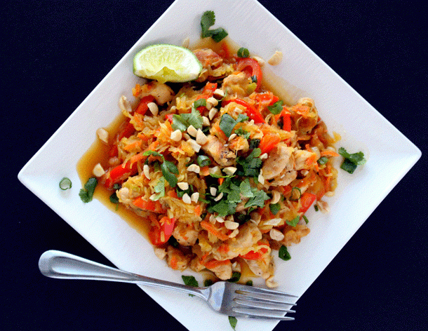
INGREDIENTS
For the pad thai:
- 1 pound skinless, boneless chicken breast // can sub for vegetarian option (Tofu, beans, or mixture!)
- 1 large spaghetti squash
- 2 large carrots, grated
- 1 medium red bell pepper, thinly sliced
- 4 green onions, thinly sliced, plus more for garnish
- 3 garlic cloves, minced
- 1/4 cup cilantro, plus more for garnish
- 1/3 cup chopped unsalted peanuts
- 2 tablespoons extra virgin olive oil
Nutrition Information
~ Serves: 6 | Serving Size: 3/4 cup
Per serving: Calories: 274;
Total Fat: 10g; Saturated Fat: 2g; Monounsaturated Fat: 5g; Cholesterol: 40mg; Sodium: 698mg; Carbohydrate: 27g; Dietary Fiber: 4g; Sugar: 15g; Protein: 20g

For the sauce:
- 1/4 cup reduced-sodium chicken broth
- 1/4 cup rice vinegar (or substitute white vinegar)
- 2 tablespoons lime juice
- 3 tablespoons honey
- 1/4 cup tamari (gluten-free soy sauce)
- 1 teaspoon sesame oil
- 1/4 teaspoon pepper
DIRECTIONS
- Preheat oven to 350 degrees F. Cut spaghetti squash in half lengthwise and scoop out the seeds and guts. Drizzle the flesh side with olive oil and place face down on a baking sheet. Bake for about 45 minutes, until you can stick a knife in easily.
- When squash is done, remove from the oven and let it cool for about 5-10 minutes. When it is cool enough to handle, use a fork to scrape out all of the spaghetti squash, until all you have left is the skin. Set the squash in a colander for about 10 minutes to drain all of the excess moisture.
- In the meantime, make the sauce. Put all of the ingredients for the sauce into a small saucepan and whisk to combine. Put over medium-low heat to warm. Don’t let it come to a boil, just keep it warm while you are cooking the rest of the meal.
- Now cook the chicken. Cut the chicken into small pieces and season with a pinch of salt and pepper. In a large skillet over medium-high heat, add the chicken with 2 tbsp of olive oil, stir occasionally until chicken is lightly brown.
- Add the peppers, carrots, green onions and garlic, and saute for about 3-4 minutes, until vegetables are tender-crisp. Add the drained spaghetti squash and the sauce to the skillet and stir until evenly distributed.
- Remove from skillet and put the squash mixture into a large bowl. At this time, add the peanuts, and cilantro. Stir.
- To serve, garnish with a few more peanuts and cilantro.

