Slow Cooker Turkey Tacos Under 250 Calories
Turkey breast is a mean, lean source of protein. Good quality ground turkey also includes vitamin B6, which means it’s a good, healthier alternative to carnitas or carne asada.
Ingredients
- 1 teaspoon (5 ml) olive oil
- 1 white onion, chopped
- 1 pound (454 grams) 94% lean ground turkey
(use 99% lean if you desire)
- 3 cloves garlic, minced
- 1 (8-ounce) can tomato sauce (240 ml)
- 2 teaspoons (30 ml) cumin
- 2 teaspoons (30 ml) chili powder
- 1 teaspoon (5 ml) dried oregano
- 1/2 teaspoon (2.5 ml) paprika
- Pinch cayenne pepper, optional
- 3/4 teaspoon (3.75 ml) salt
- 8 corn tortillas
- 1 cup (240 ml) grape tomatoes, quartered (alternately use 1 large tomato, diced)
- 1/2 cup (120 ml) shredded cheddar cheese
- 1 avocado, diced
- Shredded lettuce
- Sliced jalapeno

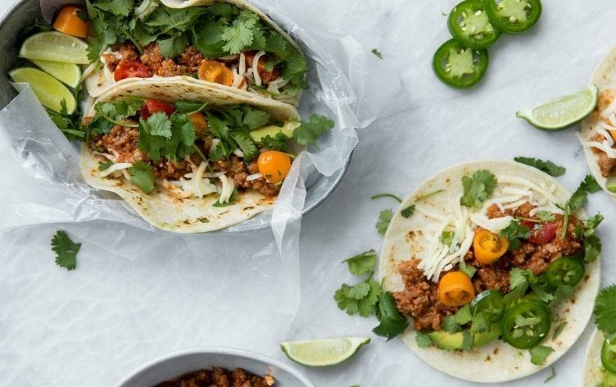

Directions
Add olive oil to a large skillet and place over medium high heat. Add onions and turkey. Cook the turkey, breaking up the meat with a wooden spoon until evenly browned. Transfer to the slow cooker and add the garlic, tomato sauce, cumin, chili powder, oregano, paprika, cayenne pepper and salt. Stir to combine. Cook on high for 2–3 hours or on low for 6–7 hours.
Once ready to serve, divide meat between 8 corn tortillas. Add grape tomatoes, cheese, diced avocado, lettuce and jalapeno slices. Serves 4. Serve topped with a dollop of Greek yogurt, if desired.
Serves: 4 | Serving Size: 2 tacoS
Nutrition (per serving): Calories: 226; Total Fat: 11g; Saturated Fat: 3g; Monounsaturated Fat: 3g; Cholesterol: 38mg; Sodium: 279mg; Carbohydrate: 18g; Dietary Fiber: 4g; Sugar: 3g; Protein: 16g

