SPAGHETTI SQUASH CHICKEN PAD THAI
Serves: 4 | Serving Size: 1 1/2 cups
Nutrition (per serving): Calories: 261; Total Fat: 8g; Saturated Fat: 1g; Monounsaturated Fat: 4g; Cholesterol: 66mg; Sodium: 421mg; Carbohydrate: 15g; Dietary Fiber: 3g; Sugar: 5g; Protein: 33g
Ingredients
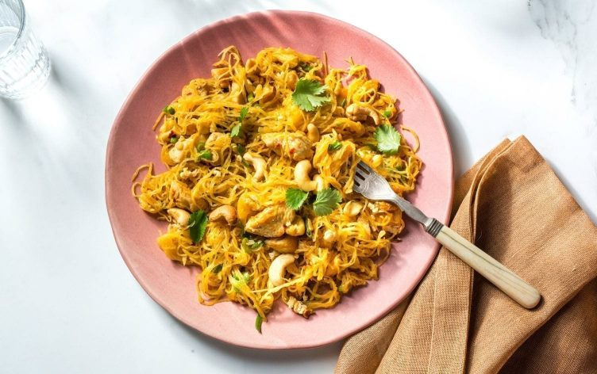
- 4 cups (620g) baked spaghetti squash, patted dry
- 2 teaspoons avocado oil
- 1 pound (450g) chicken breast, chopped
- 1 teaspoon crushed red pepper
- 4 large egg whites
- 1/2 cup (50g) green onion, chopped
- 1 tablespoon tamari soy sauce
- 1 tablespoon lime juice, freshly squeezed
- 1 teaspoon lime zest
- 1/4 cup (15g) cilantro leaves, whole
- 1/4 cup (35g) unsalted cashews, chopped
Directions
- To bake the squash: Preheat the oven to 400ºF (200ºC). Halve the squash lengthwise and scoop out the seeds, discard. Place the squash, cut-side down, on a parchment-lined baking sheet and roast for about 20 minutes. Bake the squash just until you can separate the strands with a paring knife; don’t overbake. Cool on a rack until you can handle the squash. Scoop out and separate the strands.
- Coat a large saute pan with avocado oil and place the pan over medium-high heat. Add the chicken breast and crushed red pepper and stir frequently until the chicken is cooked through, about 4 minutes. Add the egg whites and stir for a minute to cook, then add the green onions and spaghetti squash and stir.
- Mix the tamari, lime juice and zest in a cup, then drizzle over the pan, stirring to combine. When the egg whites are set, sprinkle with cilantro and cashews and serve.

