SLOW COOKER CHICKEN LENTIL SOUP
Prep Time: 5 mins // Cook Time: 4 hrs // Total Time: 4 hrs 5 mins
NUTRITION INFO | Servings: 8 people
Calories: 300kcal | Carbohydrates: 40g | Protein: 28g | Fat: 2g | Cholesterol: 36mg | Fiber: 18g | Sugar: 3g | Vitamin A: 410IU | Vitamin C: 25mg | Calcium: 82mg | Iron: 6.2mg

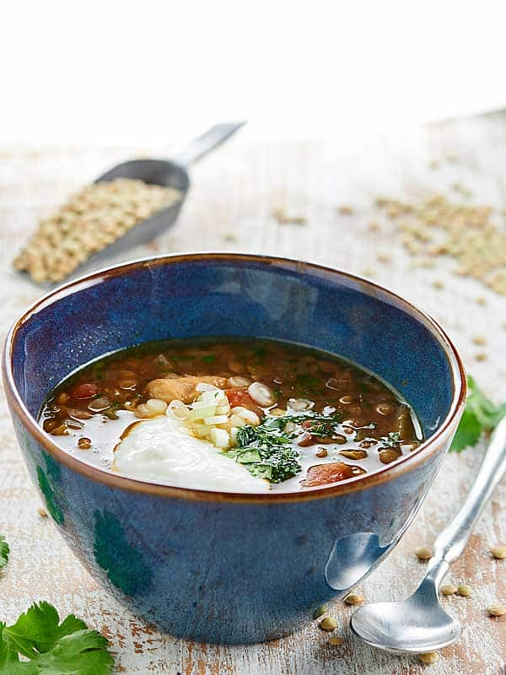
Ingredients
- 1 pound dried lentils
- 1 pound boneless skinless chicken breasts*
- 1 (15 oz) can diced tomatoes
- 1 yellow onion diced
- 4 cloves garlic minced
- 1 teaspoon garlic powder
- 1 teaspoon onion powder
- 1 1/2 teaspoons dried oregano
- 1 1/2 teaspoons chili powder
- 1 1/2 teaspoons smoked paprika
- 2 1/2 teaspoons ground cumin
- 1/2 - 1 teaspoon salt
- Cayenne if desired*
- 7 1/2 cups chicken broth
- Green onions for topping
- Cilantro for topping
- Non-fat plain greek yogurt ---for topping

Instructions
- Grease crockpot with cooking spray.
- Place all ingredients into crockpot AND COMBINE.
(WITH HOLD: green onions, cilantro, and greek yogurt—for toppings later)
- Cook on HIGH for FOUR hours or LOW for EIGHT hours.
- After the soup is done cooking, remove chicken breasts and shred them using two forks.
- Place chicken back into soup and stir to combine.
- Serve with sliced green onions, chopped cilantro, and greek yogurt!

