Roasted Red Pepper & Peanut Soup with Crispy Spiced Chickpeas
Active:25 mins; Total: 35 mins // Servings:6
Nutrition Facts: Serving Size: generous 1 cup soup & 1/4 cup crispy chickpeas
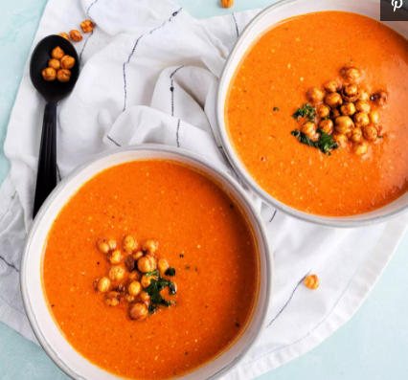
Per Serving: 344 calories; fat 19g; sodium 381mg; carbohydrates 31g; dietary fiber 10g; protein 12g; sugars 6g; niacin equivalents 1mg; saturated fat 4g; vitamin a iu 4049IU; potassium 268mg..
Ingredients
- 4 medium red bell peppers (1 3/4 pounds)
- 1 tablespoon extra-virgin olive oil
- 1 medium yellow onion, chopped
- 1 clove garlic, sliced
- 2 teaspoons ground ginger
- 3 cups low-sodium vegetable broth
- ½ cup smooth natural peanut butter
- 1 cup light coconut milk
- ¼ teaspoon salt
- ⅛ teaspoon ground pepper
- 1 ½ cups prepared spiced crispy chickpeas
Instructions: Preheat oven to 400°F.
- Cut peppers in quarters lengthwise. Remove seeds and membrane. Cut into 2-inch pieces. Transfer to a large rimmed baking sheet and roast until browned in spots, 10 to 12 minutes.
- Meanwhile, heat oil in a large saucepan over medium heat. Add onion and cook, stirring, until starting to soften, about 3 minutes. Add garlic and ginger; cook, stirring, until fragrant, about 1 minute.
- Add broth, peanut butter and the roasted peppers. Bring to a boil then reduce heat to maintain a simmer; cook, covered, until the vegetables are very soft, 8 to 10 minutes.
- Remove from heat and stir in coconut milk, salt and pepper. Using an immersion blender or regular blender, blend until smooth. (Use caution when blending hot liquids. If using a regular blender, process in batches.) Serve sprinkled with chickpeas.

