Pesto Pearl Couscous Salad
Nutrition Facts: | Servings 4.0 // @ Amount Per Serving: ¼ recipe @ calories 392
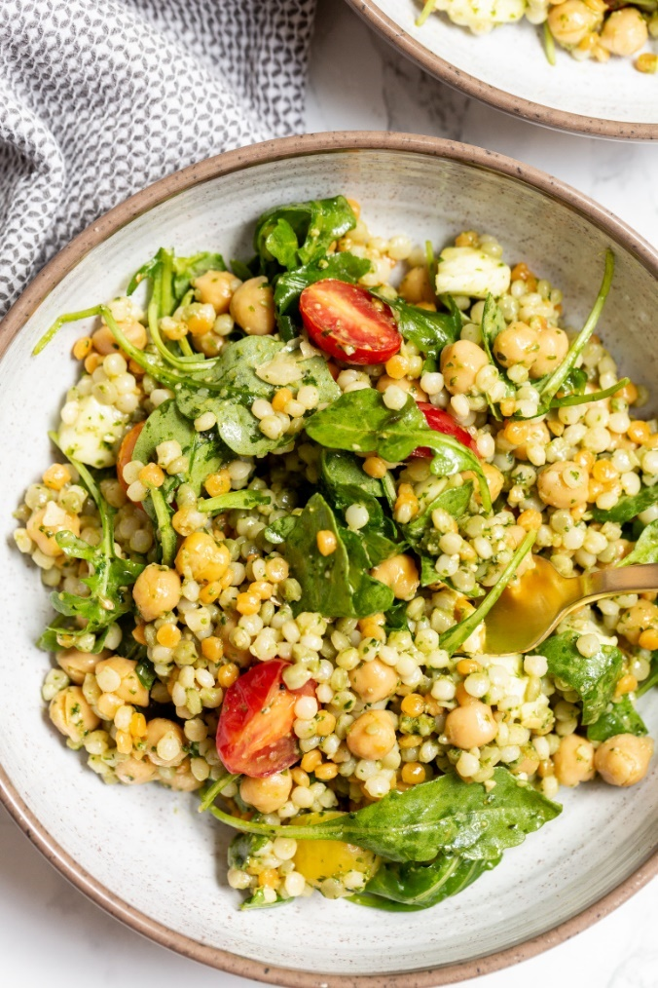
Total Fat 21g, Saturated Fat 3g, Monounsaturated Fat 0g, Polyunsaturated Fat 1g, Trans Fat 0g, Cholesterol 23 mg, Sodium 637 mg, Potassium 282 mg,Total Carbohydrate 36g, Dietary Fiber 6g, Sugars 3g, Protein 16 g
Ingredients
- 1/3 cup pesto sauce
- 3 cups cooked pearl couscous (or 1 ½ cups dry, then cook to yield 3 cups cooked)
- 1 cup halved cherry tomatoes
- 1/3 cup halved mozzarella balls
- 1½ cups baby arugula
- 1 15.5-ounce can chickpeas or white beans, drained and rinsed

Instructions
- In the bottom of a large mixing bowl, add the pesto and top with couscous and give a big stir.
- Add the tomatoes, mozzarella, arugula, and beans and stir again to combine.
- Serve.

