New York Chopped Salad
PREP TIME: 25 mins\\ TOTAL TIME: 25 mins

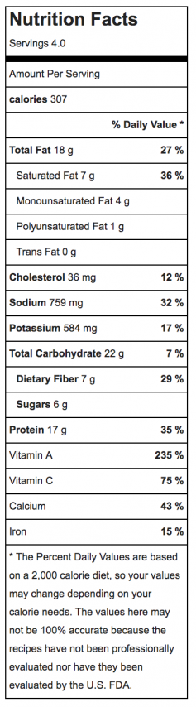
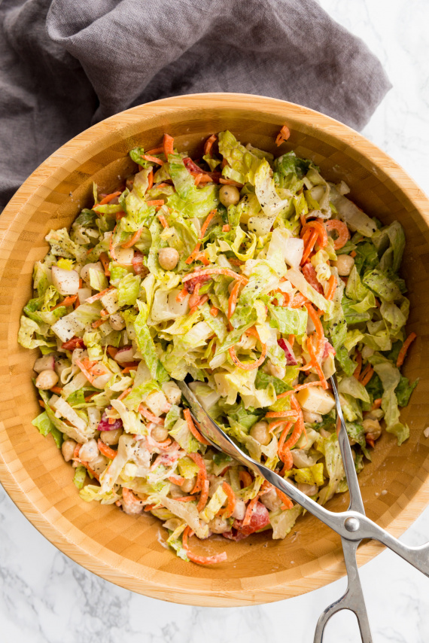
Ingredients
For the salad:
- Kosher salt
- Freshly ground black pepper
- 1 cup canned chickpeas drained and rinsed
- 8 cups shredded romaine lettuce hearts
- 1 cup diced Gruyère cheese
- 1 large carrot Blade D, noodles chopped
- ½ cup diced red radish
- ½ cup diced roasted red peppers

For the dressing:
- 2 tablespoons tahini
- 1 tablespoon water
- 1 small clove garlic minced
- 1 teaspoon freshly squeezed lemon juice
- Kosher salt
- Freshly ground black pepper

Instructions
- In a small bowl, combine all the dressing ingredients, seasoning with salt and pepper. Transfer 1 tablespoon of the dressing to a small bowl, add the chickpeas, and stir. Spoon the remaining dressing into a bowl and refrigerate, along with the bowl of chickpeas, until ready to dress the salad.
- In a large salad bowl, combine all the salad ingredients. Spoon the dressing on the salad, toss until well coated, and serve.

