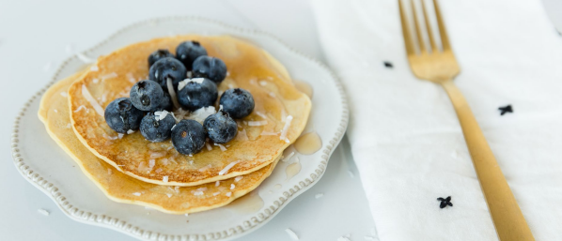
Makes 1 serving
Nutrition information: 395 calories, 14g fat, 41g carbs, 32g protein
INGREDIENTS:
- 1/3 cup rolled oats
- 1 scoop Cornerstone Wellness Vanilla Shake
- 2 tablespoons unsweetened shredded coconut
- 2 egg whites
- 1/4 cup unsweetened almond milk
- 1 1/2 tablespoons lemon juice
- Lemon zest, to taste
- Granulated stevia, to taste
- Calorie-free, sugar-free syrup, to taste (like Walden Farms)
DIRECTIONS:
1. Blend oats in a blender until flour forms.
2. Add remaining ingredients, (except for coconut, blueberries, and syrup) and blend until batter is smooth
3. Preheat a griddle to medium heat and spray with nonstick cooking spray.
4. Pour batter on preheated griddle, makes about 2 medium pancakes.
5. Allow to cook until edges are set, about 2-3 minutes, then flip and continue cooking another 1-2 minutes or until
golden brown.
6. Top pancakes with sugar-free syrup, and blueberries and Enjoy!
Notes: you can add blueberries into the mix and cook them as well!

