Kung Pao Chicken with Bell Peppers
Nutrition Facts| Serving Size: 1 cup ~ Makes: 4 servings
Per Serving: 264 calories; protein 25.2g; carbohydrates 7.4g; dietary fiber 1.6g; sugars 3.3g; fat 14.4g; saturated fat 2.5g; cholesterol 62.7mg; vitamin a iu 1107IU; vitamin c 62mg; folate 25.6mcg; calcium 21.5mg; iron 1.2mg; magnesium 40.7mg; potassium 476.6mg; sodium 459.3mg.
Active: 30 mins\\ Servings: 4
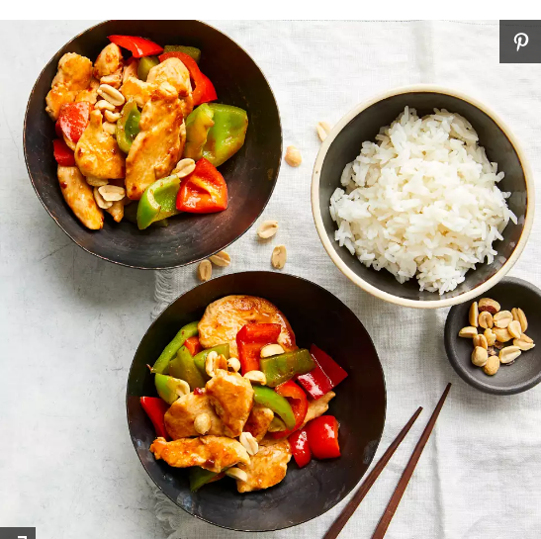
Ingredients
- 1 pound boneless, skinless chicken breast, cut into 1/4-inch-thick slices
- 2 teaspoons reduced-sodium soy sauce plus 1 Tbsp., divided
- 1 teaspoon dry sherry plus 1 Tbsp., divided
- 2 teaspoons cornstarch
- 2 teaspoons toasted sesame oil
- 2 tablespoons unsalted chicken broth
- 2 teaspoons balsamic vinegar
- 2 teaspoons chile-garlic sauce (see Tips)
- 2 tablespoons vegetable oil, divided
- 3 slices fresh ginger, peeled and smashed (see Tips)
- 1 medium red bell pepper, cut into 1-inch squares
- 1 medium green bell pepper, cut into 1-inch squares
- ¼ teaspoon salt
- 2 tablespoons unsalted dry-roasted peanuts
Instructions Checklist
- Combine chicken, 2 tsp. soy sauce, 1 tsp. sherry, and cornstarch in a medium bowl. Stir until the cornstarch is no longer visible. Add sesame oil and stir until the chicken is lightly coated.
- Combine broth, vinegar, chile-garlic sauce, and the remaining 1 Tbsp. soy sauce and 1 Tbsp. sherry in a small bowl. Set aside.
- Heat a 14-inch flat-bottomed carbon-steel wok (or a 12-inch stainless-steel skillet) over high heat until a drop of water vaporizes within 1 to 2 seconds of contact. Swirl in 1 Tbsp. vegetable oil. Add ginger; stir-fry until fragrant, about 10 seconds. Push the ginger slices to the sides and add the chicken in an even layer. Cook, undisturbed, until it begins to brown, about 1 minute. Using a metal spatula, stir-fry the chicken until lightly browned but not cooked through, about 1 minute more. Transfer to a plate.
- Swirl in the remaining 1 Tbsp. vegetable oil. Add bell peppers; stir-fry for 1 minute. Return the chicken to the pan along with the reserved sauce; season with salt and stir-fry until the chicken is cooked through, 1 to 3 minutes. Remove from heat and sprinkle with peanuts.
Tips: You can find chile-garlic sauce in the Asian-foods aisle of most major grocery stores. It is a red sauce often sold in a clear plastic jar. If you can't find it, you can add 1/2 tsp. crushed red pepper and 1 tsp. minced garlic with the ginger in Step 3.

