INSTANT POT LENTIL BOLOGNESE
Servings 2 \ calories per serving 458
Nutrition Facts| Calories 458
Total Fat 7g, Saturated Fat 6g, Monounsaturated Fat 0g, Polyunsaturated Fat 0 g, Trans Fat 0 g, Sodium 486 mg, Total Carbohydrate 88g, Dietary Fiber 15g, Sugars 12g, Protein 20 g
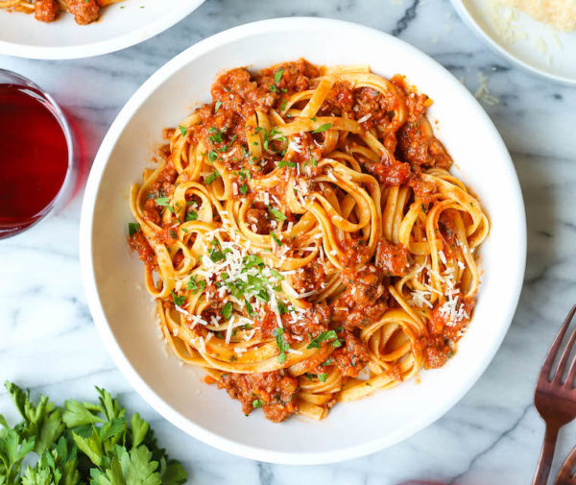
INGREDIENT
1/2 cup chopped Onion
1 Celery Stalk
1 cup, chopped, Carrots
1/2 cup Bella / Crimini Mushrooms
2 clove, Garlic
1 tbs tomato Paste
1/8 cup, Red Wine
½ cup dry/32g, Dried Lentils
¼ cup Water
1 Bay Leaf
1 tsp thyme, dried
1 tsp, oregano, dried
1 tbsp Balsamic Vinegar
1 tbsp Ground Black Pepper
1 ounce Pecorino Romano
1 cup Fresh Basil
4 ounces Penne whole grain or whole wheat
2 ½ cups No Salt Added Crushed Tomatoes
Instructions
- Press the Sauté function key on your Instant Pot and heat the olive oil. Add the onion, celery, and carrots and season with salt and pepper. Keep the lid off and sauté for 5 minutes, or until the onions are clear and the vegetables are soft.
- Add the mushrooms and garlic. Cook for 4 to 5 minutes, or until the mushrooms are soft and have released some liquid and the garlic is fragrant. Add the tomato paste and stir to incorporate, let brown for 2-3 minutes. Add the red wine and stir, scraping any browned bits from the bottom of the pot, let evaporate.
- Add the lentils, tomatoes, water, and spices to the Instant Pot, close the steam release knob and set to manual for 20 minutes. Now is a good time to cook your pasta. When the Lentil Bolognese sauce is done cooking, allow the pressure to release naturally for 10 minutes. Stir in the balsamic vinegar, taste and adjust seasoning with salt and pepper. Serve over cooked pasta and top with grated cheese and fresh basil.

