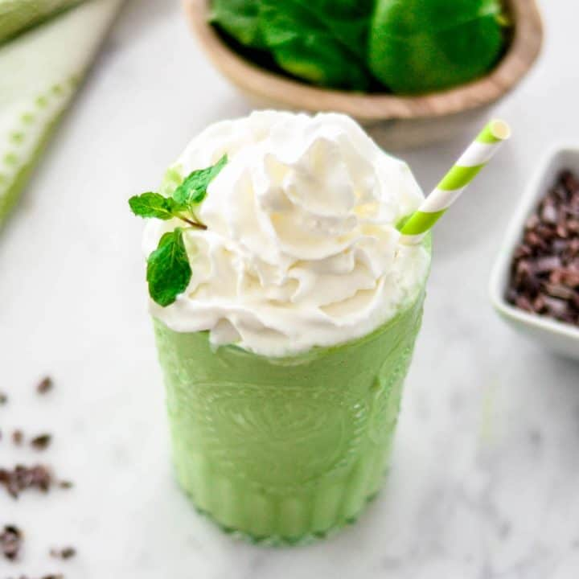
HEALTHY SHAMROCK SHAKE
PREP TIME: 2 min Total Time: 5 mins
NUTRITION PER Serving:1 @ Calories 313 || Total Fat 12g, Saturated Fat 2g, Monounsaturated Fat 7 g, Polyunsaturated Fat 1 g, Trans Fat 0g, Total Carbohydrate 30g, Dietary Fiber 7g, Sugars 22 g, Protein 21 g 42 %

INGREDIENTS
- 1/2 cup milk (low fat, 2%)
- ¾ cup vanilla Greek yogurt— 15-20 g protein
- ½ a small avocado
- ½ tsp pure vanilla extract
- ½ cup spinach frozen
- 6 fresh mint leaves, or ½ TSP mint extract
- 1 tsp honey
- ½ CUP ice-- optional

INSTRUCTIONS
- Add ingredients to your Vitamix (or other high-powered blender) in the order listed.
- Blend, starting on low speed and gradually increasing to high until your mixture is smooth and homogenous.
- Pour and serve immediately, top with whipped cream or chocolate!
NOTES: Ingredient Substitutions
- Greek Yogurt/Milk: If you avoid dairy, you can easily substitute a dairy-free yogurt and almond or coconut milk to make this dairy-free! I Recommend using honey or vanilla flavored yogurt. If you use plain yogurt, you will need to increase the amount of honey so that it's sweet enough.
- Spinach. Use frozen spinach to make a thick and creamy shake.
- Honey: Use any liquid sweetener of your choice.
- Mint: If you'd prefer, you can use mint extract instead of fresh mint, however I love the flavor the fresh mint imparts in this healthy shamrock shake!

