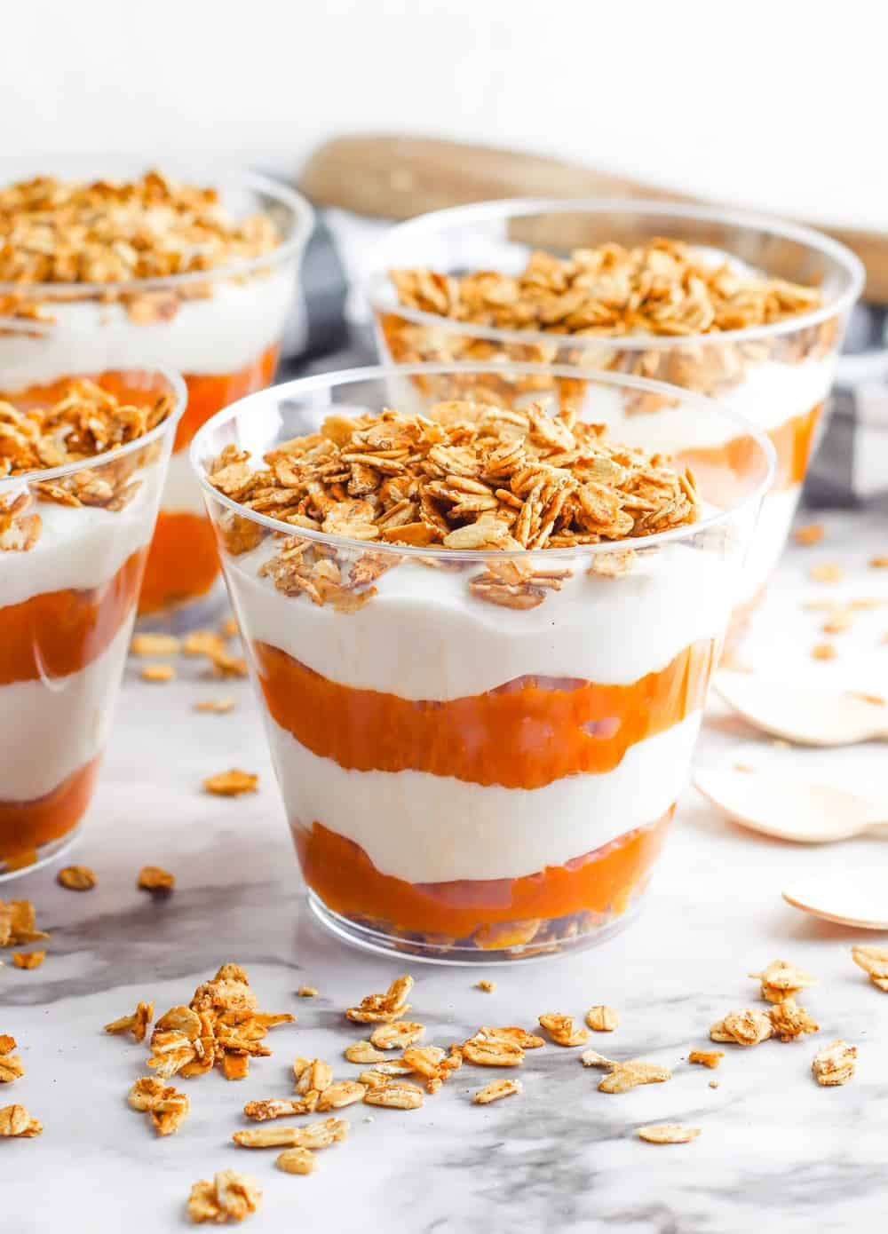
HIGH PROTEIN PUMPKIN PARFAITS
Makes 2 servings
Nutrition: 250 Calories-- Total Fat: 10.3g, fiber 3.2g, sugar 13.1g, protein: 17.7g,
INGREDIENTS
- 12 oz (1.5 cups) NON-FAT Vanilla Greek Yogurt
- ¾ canned pumpkin puree
- ½ tsp Ground cinnamon sprinkled ontop * * *
- * Optional:
  - 1/8 cup chopped walnuts, pecans, or granola

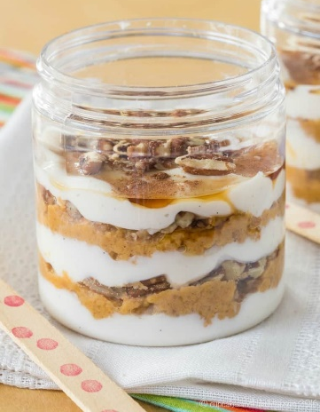
INSTRUCTIONS:
split all ingredients in half and reserve---
LAYER all ingredients : )
½ cup pumpkin puree per mason jar
¾ cup NF Greek vanilla yogurt
¼ cup chopped nuts/granola—save to top

