Green Goddess Salad with Chickpeas
Total:15 mins// Active:15 mins Servings:2
Nutrition| Serving Size: 2 3/4 cups
Per Serving | 304 calories
~ Protein 21.7g; carbohydrates 39.8g; dietary fiber 11.9g; sugars 10.1g; fat 7.5g; saturated fat 1.7g; cholesterol 12mg; vitamin a iu 6774.1IU; vitamin c 14mg; folate 180.9mcg; calcium 420mg; iron 2.5mg; magnesium 71.8mg; potassium 641.4mg; sodium 465mg.

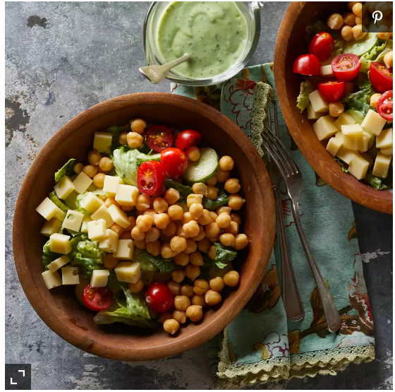
Ingredients
Dressing
- 1 avocado, peeled and pitted
- 1 ½ cups buttermilk
- ¼ cup chopped fresh herbs--such as tarragon, sorrel, mint, parsley and/or cilantro
- 2 tablespoons rice vinegar
- ½ teaspoon salt
Salad
- 3 cups chopped romaine lettuce
- 1 cup sliced cucumber
- 1 (15 ounce) can chickpeas, rinsed
- ¼ cup diced low-fat Swiss cheese
- 6 cherry tomatoes, halved if desired
Directions
- To prepare dressing: Place avocado, buttermilk, herbs, vinegar and salt in a blender. Puree until smooth.
- To prepare salad: Toss lettuce and cucumber in a bowl with 1/4 cup of the dressing. Top with chickpeas, cheese and tomatoes. (Refrigerate the extra dressing for up to 3 days.)
Tips: To make ahead: Cover and refrigerate leftover dressing for up to 3 days.

