Greek Chicken & Orzo Skillet
Serves: 4 | Serving Size: About 1 1/4 cups
Per serving: Calories: 407; Total Fat: 12g; Saturated Fat: 3g; Monounsaturated Fat: 4g; Cholesterol: 96mg; Sodium: 618mg; Carbohydrate: 49g; Dietary Fiber: 8g; Sugar: 4g; Protein 39g
Ingredients
- 1 tablespoon olive oil
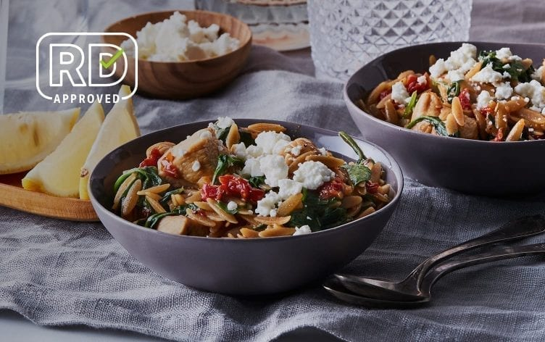
- 1 pound (454g) boneless, skinless chicken breasts, cubed
- 3/4 teaspoon kosher salt, divided
- 1/2 teaspoon black pepper, divided
- 3 garlic cloves, minced
- 2 cups (473ml) unsalted chicken stock
- 1 cup (150g) whole-wheat orzo, uncooked
- 1/3 cup (28g) chopped sun-dried tomatoes (not in oil)
- 1 teaspoon dried oregano
- 6 ounces (170g) fresh baby spinach
- 1/3 cup (43g) crumbled feta cheese
- 1 lemon, cut into wedges
Directions
- Heat a large skillet over medium-high heat. Add oil to the pan and swirl to coat. Add chicken to the pan and sprinkle with 1/4 teaspoon each salt and pepper. Saute 3 minutes or until just starting to brown. Add garlic to pan; saute 2 minutes.
- Stir in chicken stock, orzo, tomatoes, oregano and remaining 1/2 teaspoon salt and 1/4 teaspoon pepper. Bring to a boil. Cover, reduce heat to medium-low, and cook until orzo is tender, about 15 minutes, stirring occasionally to keep pasta from sticking to pan.
- Uncover pan. Gradually add spinach, stirring until wilted. Sprinkle with cheese and serve with lemon wedges.

