Greek Chicken Salad
Prep time: 15 min// Servings: 4
Nutrition Facts| Amount per serving: (Serving size: about 2 heaping cups) @ Calories: 340
Total Fat 19g, Saturated Fat 4g, Trans Fat 0g, Cholesterol 65mg, Sodium 410mg, Total Carbohydrate 16g, Dietary Fiber 4g, Total Sugars 3g, Added Sugars 0g, Protein 25g, Potassium 530mg, Phosphorus 240mg// * * * Choices/Exchanges: 1 Non-starchy vegetable, 1/2 Starch, 3 Lean protein, 3 Fat * *
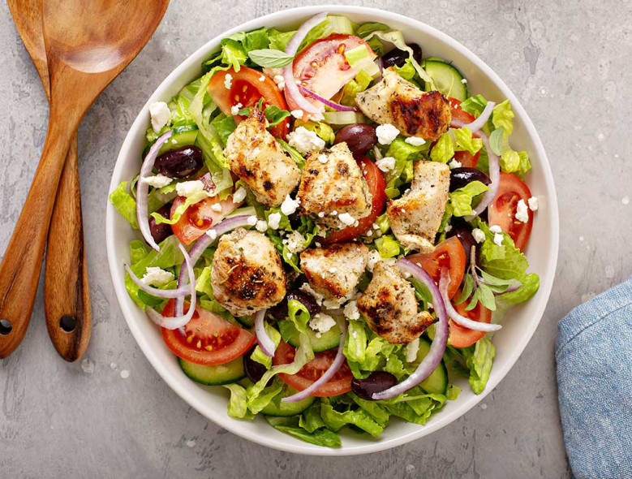
Ingredients
- 1 (9-oz) bag chopped romaine lettuce
- 1 medium cucumber (peeled + diced)
- 2 roma tomatoes (diced)
- 16 pitted kalamata olives (cut in half)
- 1 small red onion (thinly sliced)
- ½ reduced-fat crumbled feta cheese
- 1/4 cup diced cooked chicken (diced)
- 2 cup red wine vinegar
- 1/4 cup olive oil
- 3 tbsp Dijon Mustard
- 1/4 tsp dried oregano
- 1/2 tsp black pepper
- 1/8 tsp baked whole wheat pita chips
- 16 chips (about 1 1/2 oz total)

Directions
- In a medium bowl, mix together the lettuce, cucumber, tomatoes, olives, red onion, cheese, and chicken. For meal prepping, evenly divide the salad between 4 meal prep containers (about 2 heaping cups each).
- In a small bowl, whisk together the vinegar, olive oil, mustard, oregano, and pepper.
- Pour the dressing over the salad and toss to coat. Or, store the dressing separately, and drizzle over the salad just before serving.
- Enjoy the pita chips on the side or break into bits and sprinkle over your salad for added crunch.
DIY: Try making your own pita chips! Use 1 whole wheat pita (6 1/2" diameter or about 2 oz.). Cut the pita in half and cut then each half into quarters. Separate each piece for a total of 16. Place on rimmed baking sheet and spray lightly with olive oil nonstick spray. Turn over each piece and spray the other side. Bake at 375 degrees F for about 10 minutes or until crisp.

