GARLIC PARMESAN BAKED HALIBUT
Prep Time: 5 Minutes // Cook Time: 10 Minutes // Total Time: 15 Minutes
Nutrition Facts: Servings 4.0 | Amount Per Serving
calories 371| Total Fat 28 g, Saturated Fat 11g, Monounsaturated Fat 7 g, Polyunsaturated Fat 9 g, Trans Fat 0 g, Total Carbohydrate 4 g, Dietary Fiber 0 g, Sugars 0 g, Protein 26 g
For The Topping Ingredients:
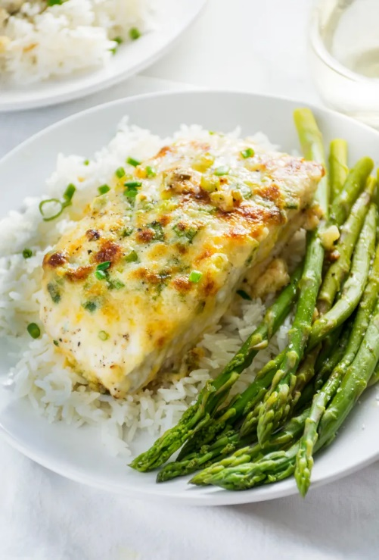
- ¼ cup butter, softened
- ¼ cup mayonnaise
- ½ cup freshly grated Parmesan cheese
- 2 Tbsp green onion, finely chopped
- 4-6 cloves garlic, crushed
- Dash of Tabasco
Fish Ingredients:
- Salt and pepper, to taste
- ½ lemon, juiced
- 4 halibut filets (1" thick) @ 3 oz per filet
Directions:
- Preheat oven to 450.
- Season halibut with salt, pepper and a squeeze of lemon juice.
- Place filets in a baking dish. Bake for 6 minutes.
- Mix all topping ingredients together. Remove halibut from oven and spread Parmesan mixture over top and sides of fish.
- Turn oven to broil and cook for 2-3 minutes, until the tops are lightly browned.
* *I like to top it with Tarragon as well but that is optional!
- Serve immediately with rice or potato, and asparagus.
* * * * Try this with any white fish and its superb!! * * *

