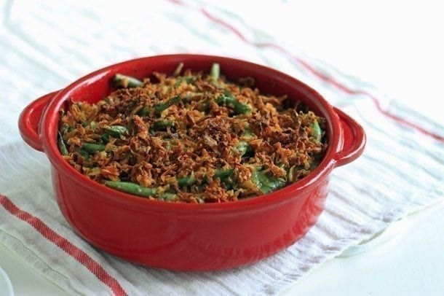
Fresh Green Bean Casserole
Serves about 8
Serving Size: 1 cup
Directions
1. Preheat oven to 350F and lightly spray a 2-quart baking dish with cooking oil.
2. For crunchy beans, steam over a pot of boiling water until bright green and still crisp, about 3 minutes. For more tender beans, blanch in boiling water for 2-3 minutes, drain and then immediately submerge in an ice bath.
3. Heat olive oil in a large nonstick skillet over medium-high heat. Add the mushrooms and cook for about 12 minutes, until liquid has evaporated and they begin to brown. Add the garlic and thyme and cook for an additional 1 minute.
4. Combine mushroom mixture, salt, pepper and parsley in a food processor and process until smooth, about 1 minute.
5. Whisk the milk and flour together in a small saucepan until the flour has dissolved. Bring to a simmer over medium heat while whisking constantly until the mixture has thickened to a yogurt consistency, about 8-10 minutes. Remove the pan from the heat. Allow to cool for 5-10 minutes before combining with Greek yogurt and mushroom mixture.
6. Toss green beans in sauce and spoon into the prepared dish. Sprinkle the top with French fried onions. Bake uncovered for 15-20 minutes. Serve warm.

Nutrition (per serving):
Calories: 139; Total Fat: 6g; Saturated Fat: 2g; Cholesterol: 3mg; Sodium: 244mg; Carbohydrate: 17g; Dietary Fiber: 4g; Sugar: 3g; Protein: 7g
Ingredients
- 1 1/2 pounds fresh green beans, ends trimmed and chopped into 1-inch pieces
- 2 teaspoons olive oil
- 8 ounces white or baby bella mushrooms, diced
- 6 cloves garlic, chopped
- 1 tablespoon thyme, dried or fresh
- 1 1/2 cups 1% milk
- 3/4 cup 2% Greek yogurt
- 3 tablespoons all-purpose flour
- 1/2 cup finely chopped fresh parsley
- 1/2 teaspoon salt
- 1/4 teaspoon pepper
- 1 cup French Fried Onions

