FIVE SPICE HEALTHY MASHED SWEET POTATOES
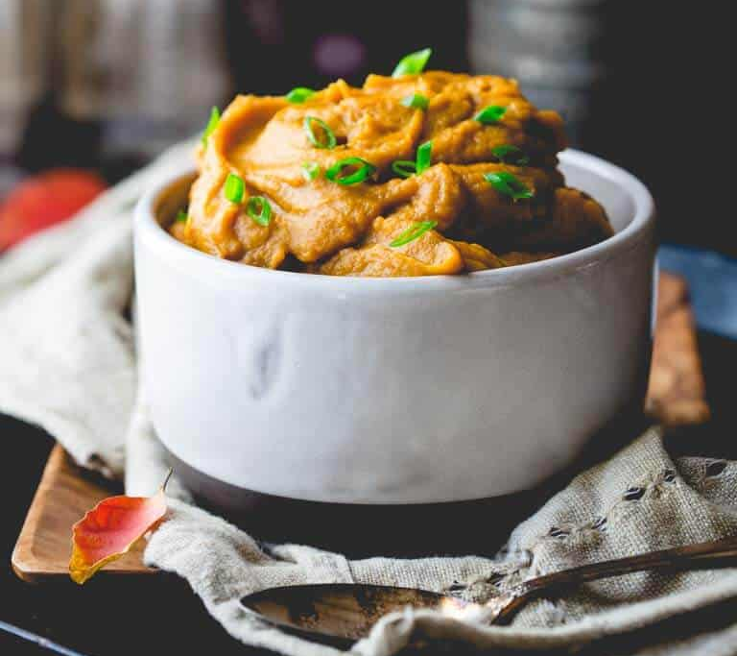
INGREDIENTS
- 3 pounds sweet potatoes peeled and cut into 2-inch chunks
- 1/4 cup coconut oil
- 1 clove garlic chopped
- 1 teaspoon grated ginger
- 2 teaspoons Chinese 5 Spice
- 1 orange zested and juiced
- 1 1/4 teaspoons salt
INSTRUCTIONS
- Bring 1 to 2 inches of water to a boil in a large saucepan fitted with a steamer basket over high heat. Add potatoes to the basket, cover and steam until a fork can be easily pressed into the potatoes and pulls out without resistance, 19 to 22 minutes.
- Meanwhile, melt coconut oil in a small saucepan over medium heat. Add garlic and cook until fragrant and just starting to brown. Add ginger and 5-spice and stir to combine. Remove from the heat and immediately and CAREFULLY stir in juice from the orange to stop the spices from over cooking. Stir in ½ teaspoon zest and salt until the salt is dissolved.
- Remove the steamer basket from the saucepan. Transfer the sweet potatoes to a food processor fitted with the steel blade attachment. Scrape coconut oil mixture into the food processor. Puree, scraping down the sides and mixing together once or twice, until completely smooth. Alternatively, for a more rustic texture, pour the boiling water out of the saucepan, and dump the cooked sweet potatoes out of the basket into the hot saucepan. Pour the coconut oil mixture over the sweet potatoes and mash with a potato masher until smooth.

NUTRITION
CALORIES: 175, SUGAR: 12 g, SODIUM: 348 mg, FAT: 10 g, SATURATED FAT: 8 g
CARBOHYDRATES: 27 g, FIBER: 3 g, PROTEIN: 2 g

