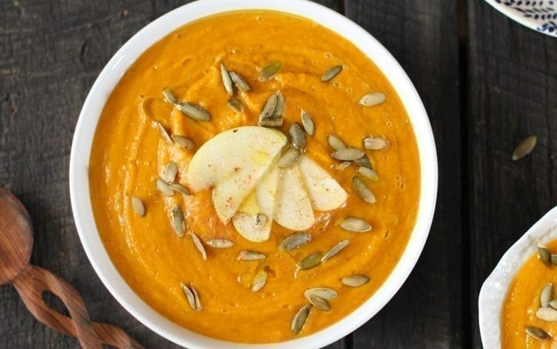
Creamy Butternut Squash and Apple Soup
Ingredients
- 5 cups (500g) butternut squash, peeled and cubed (after roasting)
- 4 cups (950ml) unsweetened almond milk
- 3 cups filtered water
- 1 large apple (approx. 1 cup)
- 1/2 cup (75g) chopped carrots
- 1/4 cup (40g) sweet onion, diced
- 2 large garlic cloves
- 2 large dates, pitted
- 2 tablespoons coconut oil
- 2 teaspoons of ground cinnamon
- 1 teaspoon sea salt, to taste
- 1/2 teaspoon ground black pepper
- 1 medium orange, juiced

Directions
Preheat oven to 450ºF (230ºC). Line a baking sheet with foil and grease lightly with coconut oil (by spreading or dolloping on the bottom).
Using a sharp vegetable peeler, peel the butternut squash while whole until the thick skin has been removed and you’re left with the bright orange flesh. After peeling, cut squash long ways (creating 2 halves). Scoop the seeds from the wide end of the butternut squash, using a spoon. Cut remaining butternut squash pieces into 1-2 inch cubes.
Spread the cubed and peeled butternut squash cubes onto the lined and greased baking sheet. Season with salt, pepper, garlic, and a dash of cinnamon. Bake at 450ºF (230ºC) for 30 minutes or until soft (you can bake longer to create a more caramelized end product, upwards to 45 minutes).
In a skillet, sauté the onions and garlic until soft and fragrant. Add roasted butternut squash, sautéed onions and garlic and all remaining ingredients into a Vitamix, high speed blender, emersion blender, food processor and blend until smooth and creamy. Keep chilled until serving.
Serve warm/hot and garnish with classic cashew cheese or crunchy walnut, pumpkin seeds.
Nutrition Information
Serves: 6 | Serving Size: 1 cup
Per serving: Calories: 202; Total Fat: 7g; Saturated Fat: 4g; Monounsaturated Fat: 1g; Cholesterol: 0mg; Sodium: 497mg; Carbohydrate: 37g; Dietary Fiber: 9g; Sugar: 17g; Protein 3g
Nutrition Bonus: Potassium: 692mg; Iron: 9%; Vitamin A: 283%; Vitamin C: 88%; Calcium: 41%

