CHILI LIME GRILLED SALMON
Nutrition Facts
Servings 4.0| Amount Per Serving: Calories 484
Total Fat 25g, Saturated Fat 7g, Monounsaturated Fat 3g,Total Carbohydrate 21g, Dietary Fiber g, Sugars 18g, Protein 44g,
INGREDIENTS
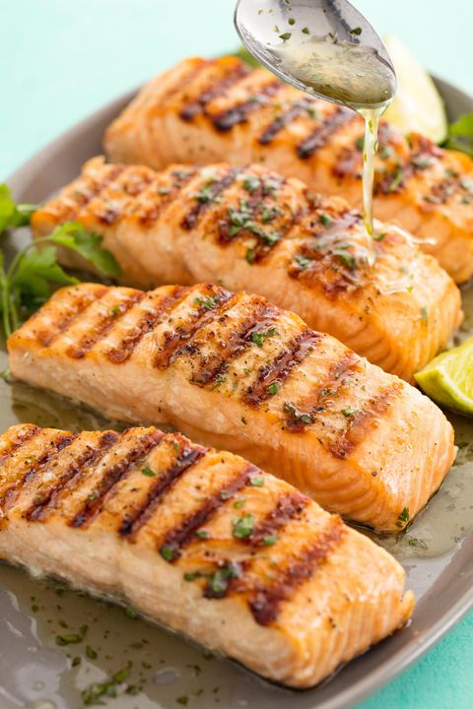
4 (6-oz.) salmon fillets
Kosher salt
Freshly ground black pepper
4 tbsp. butter
1/2 c. lime juice
1/4 c. honey
2 garlic cloves, minced
2 tbsp. Chopped cilantro

DIRECTIONS
- Season salmon with salt and pepper. Heat grill and place salmon on grill flesh side down. Cook for 8 minutes then flip and cook on other side until salmon is cooked through, 6 minutes more. Let rest 5 minutes.
- Meanwhile make sauce: In a medium saucepan over medium heat, add butter, lime juice, honey, and garlic. Stir until butter is melted and all ingredients are combined. Turn off heat and add cilantro.
- Pour sauce over salmon and serve.

Pair with:
  - 1-2 cups of veggies on the grill
  - Frozen veggies in a bag
  - Or a fresh salad!
  - Pick a starch: ½ cup cooked rice, 1 small baked potato, 1 slice of fresh bakery bread, ½ corn cobb

