CALIFORNIA GRILLED CHICKEN
YIELDS:4 SERVINGS/ PREP TIME:0 HOURS 20 MINS
TOTAL TIME:0 HOURS 40 MINS
Nutrition Facts: Servings 4.0
Amount Per Serving: Calories 285|
Total Fat 14 G, Saturated Fat 4g, Monounsaturated Fat 9 G, Polyunsaturated Fat 1g, Total Carbohydrate 26 g, Dietary Fiber 2 g, Sugars 23g, Protein 13g
INGREDIENTS
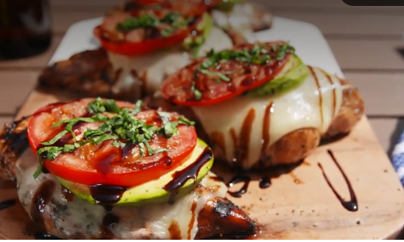
- 3/4 c. balsamic vinegar
- 1 tsp. garlic powder
- 2 tbsp. honey
- 2 tbsp. extra-virgin olive oil
- 2 tsp. Italian seasoning
- Kosher salt
- Freshly ground black pepper
- 4 boneless skinless chicken breasts
- 4 slices mozzarella
- 4 slices avocado
- 4 slices tomato
- 2 tbsp.
- Freshly sliced basil, for garnish
- Balsamic glaze, for drizzling

DIRECTIONS
- In a small bowl, whisk together balsamic vinegar, garlic powder, honey, oil, and Italian seasoning and season with salt and pepper. Pour over chicken and marinate 20 minutes.
- When ready to grill, heat grill to medium-high. Oil grates and grill chicken until charred and cooked through, 8 minutes per side.
- Top chicken with mozzarella, avocado, and tomato and cover grill to melt, 2 minutes.
- Garnish with basil and drizzle with balsamic glaze.
- Pair with 1-2 cups of veggies, fresh or frozen, or a fresh salad !

