Buffalo Chicken Dip
Prep time: 15 min// Cook time: 30 min
Nutrition Facts: | Amount per serving: Calories: 85 @ Servings:16 Servings @ Serving size: 1/4 cup
Total Fat 6g, Saturated Fat 3g, Trans Fat 0g, Cholesterol 30mg, Sodium 110mg, Total Carbohydrate 2g, Dietary Fiber 0g, Total Sugars 0g, Added Sugars 0g, Protein 6g, Potassium 90mg, Phosphorus 55mg
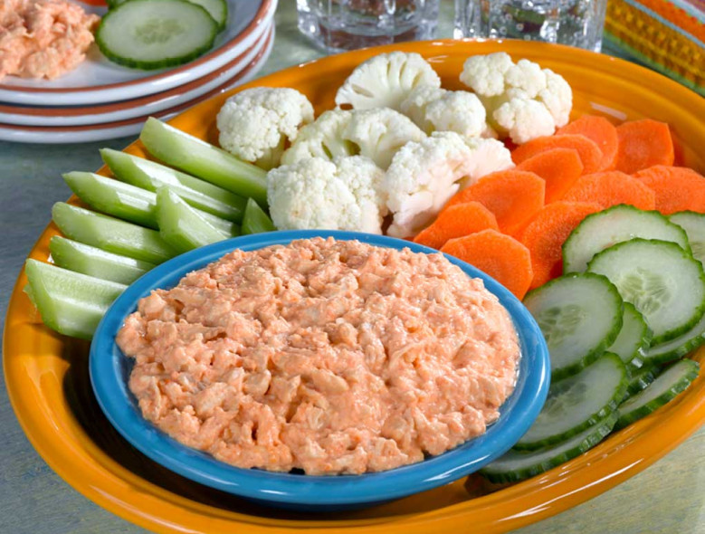
Ingredient
- roasted red peppers (drained)--1/2 cup
- cream cheese (softened)- 4 oz
- reduced-fat sour cream- 1 cup
- hot sauce- 2 tsp
- cooked shredded chicken- 2 cup
Directions
- Puree drained red peppers in a blender or food processor to make red pepper sauce.
- In a medium bowl mix cream cheese and sour cream together until smooth. Add pureed peppers and 2 teaspoons of Tabasco sauce. Stir until combined. Add the chicken and gently mix. Taste and add additional hot sauce if desired.
- Place mixture in a slow cooker for 2 to 3 hours on low heat,or bake in the oven at 350° F for 30 minutes.
Serve warm dip with:
- carrots, celery, cucumber, cauliflower for dipping
- make mini roll-ups by wrapping dip inside lettuce or cabbage leaves
- crackers or spread onto low carb tortillas, and serve as pin wheels

