3-Ingredient Goat Cheese Pasta with Broccoli
Active:10 mins, Total:15 mins // Servings:2
Nutrition Facts| Per Serving: 292 calories; fat 11g; cholesterol 12mg; sodium 232mg; carbohydrates 37g; dietary fiber 10g; protein 21g; sugars 6g; niacin equivalents 1mg; saturated fat 5g; vitamin a iu 2130IU.
Ingredients
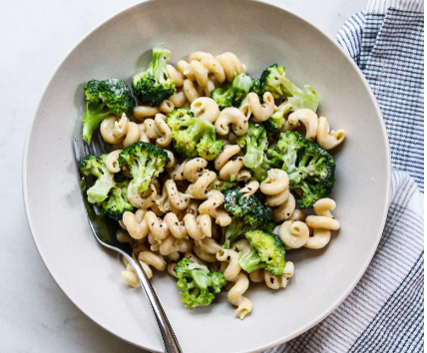
- 4 ounces chickpea cavatappi pasta
- 2 ounces garlic-and-herb-flavored goat cheese
- 2 cups cooked broccoli florets
Instructions
- Cook pasta according to package directions; drain, reserving ½ cup cooking water
- Return the drained pasta to the pot and add goat cheese. Stir until the cheese melts and coats the pasta, adding the reserved pasta water as needed to make a thin sauce.
- Fold in broccoli. Season to taste with salt and pepper, if desired.
Notes:
Swap out regular pasta for pasta made with chickpeas and you'll more than triple the fiber and double the protein in this simple, satisfying dish. Be sure to save some of the pasta water to make a sauce. Feel free to use frozen broccoli in a pinch (you can blanch the broccoli in the same water you use to cook the pasta).
Add additional protein like grilled chicken to the dish!!
EX) 3 oz skinless chicken breast = 120 calories @ 23 g protein

