Balsamic Bacon Brussels Sprouts
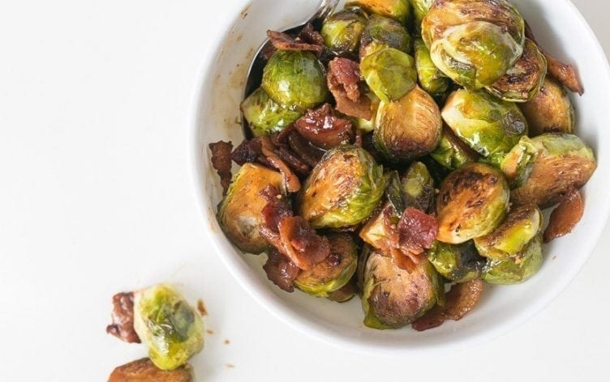
Ingredients
- 1 pound Brussels sprouts, halved
- 6 slices bacon, chopped
- 1 tablespoon balsamic vinegar
- 1 tablespoon brown sugar
- 2 teaspoons Dijon mustard (certified gluten-free if necessary)
- 1/2 medium lemon, juiced

Directions
Place Brussels sprouts in a microwave-safe dish. Add a splash of water, cover with a wet paper towel, and microwave for 2–3 minutes. (Or boil in salted water for about 2 minutes.)
Place a large nonstick skillet over medium-high heat. Add bacon, and sauté until brown and a bit crispy, about 5 minutes. Drain all but 1 tablespoon of the bacon drippings. If the pan looks too dry, add a splash of water before scraping up your bacon bits.
Add Brussels sprouts to pan, and sauté for about 5 minutes, or until they are golden on the outside.
Add balsamic vinegar, brown sugar, Dijon mustard and 2 tablespoons water to the pan. Sauté for another 1–2 minutes. Remove from heat, and top with lemon juice. Season to taste with salt and pepper. Enjoy!
Nutrition Information
Serves: 4 | Serving Size: 1 cup
Per serving: Calories: 136; Total Fat: 5g; Saturated Fat: 2g; Monounsaturated Fat: 0g; Cholesterol: 15mg; Sodium: 316mg; Carbohydrate: 16g; Dietary Fiber: 5g; Sugar: 7g; Protein: 9g
Nutrition Bonus: Potassium: 478mg; Iron: 11%; Vitamin A: 19%; Vitamin C: 178%; Calcium: 5%

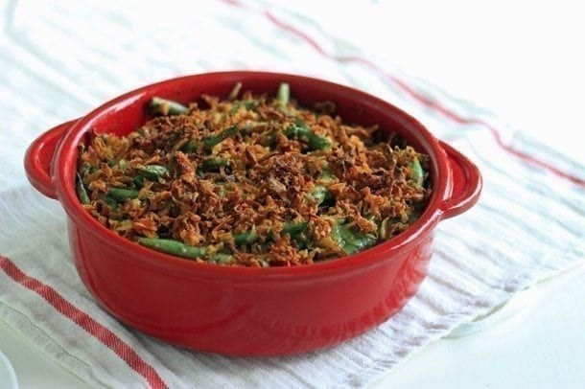
Fresh Green Bean Casserole
Serves about 8
Serving Size: 1 cup
Directions
1. Preheat oven to 350F and lightly spray a 2-quart baking dish with cooking oil.
2. For crunchy beans, steam over a pot of boiling water until bright green and still crisp, about 3 minutes. For more tender beans, blanch in boiling water for 2-3 minutes, drain and then immediately submerge in an ice bath.
3. Heat olive oil in a large nonstick skillet over medium-high heat. Add the mushrooms and cook for about 12 minutes, until liquid has evaporated and they begin to brown. Add the garlic and thyme and cook for an additional 1 minute.
4. Combine mushroom mixture, salt, pepper and parsley in a food processor and process until smooth, about 1 minute.
5. Whisk the milk and flour together in a small saucepan until the flour has dissolved. Bring to a simmer over medium heat while whisking constantly until the mixture has thickened to a yogurt consistency, about 8-10 minutes. Remove the pan from the heat. Allow to cool for 5-10 minutes before combining with Greek yogurt and mushroom mixture.
6. Toss green beans in sauce and spoon into the prepared dish. Sprinkle the top with French fried onions. Bake uncovered for 15-20 minutes. Serve warm.

Nutrition (per serving):
Calories: 139; Total Fat: 6g; Saturated Fat: 2g; Cholesterol: 3mg; Sodium: 244mg; Carbohydrate: 17g; Dietary Fiber: 4g; Sugar
Ingredients
- 1 1/2 pounds fresh green beans, ends trimmed and chopped into 1-inch pieces
- 2 teaspoons olive oil
- 8 ounces white or baby bella mushrooms, diced
- 6 cloves garlic, chopped
- 1 tablespoon thyme, dried or fresh
- 1 1/2 cups 1% milk
- 3/4 cup 2% Greek yogurt
- 3 tablespoons all-purpose flour
- 1/2 cup finely chopped fresh parsley
- 1/2 teaspoon salt
- 1/4 teaspoon pepper
- 1 cup French Fried Onions

