Baked Ziti Casserole
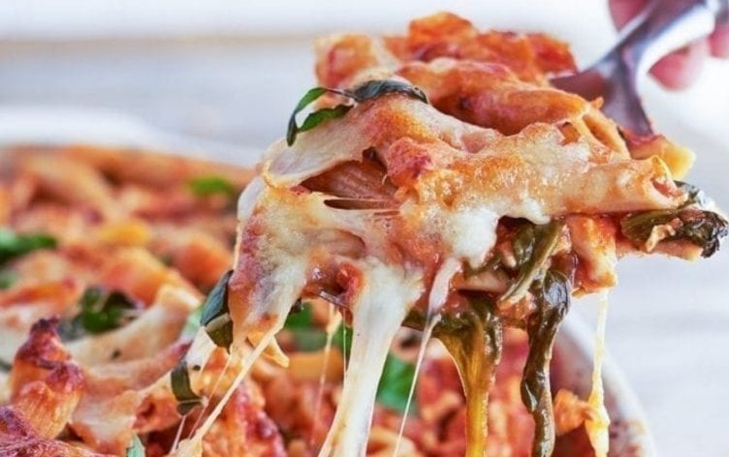
Artichoke and spinach are the secret ingredients to bulking up classic baked ziti.

Ingredients
- 4 ounces (115 g) uncooked whole-grain ziti or penne pasta
- 1 pound (450 g) lean (99/1) ground turkey
- 1 small (70 g) onion, chopped
- 3 cloves garlic, minced
- 1 (24-ounce or 720 g) jar no-salt-added marinara sauce
- 1/2 teaspoon salt
- 5 ounces (140 g) fresh baby spinach
- 1 (12-ounce or 335 g) package frozen artichoke hearts, thawed and chopped
- 1 cup (4 ounces or 110 g) shredded part-skim mozzarella cheese
- 2 tablespoons chopped fresh basil, divided

Directions
Preheat oven to 350°F (177°C).
Cook pasta in boiling water for 8 minutes or until tender. Drain and return to pot or transfer to a large bowl.
While pasta cooks, spray a nonstick skillet with cooking spray, and place over medium heat. Cook turkey, onion, and garlic for 5 minutes, until turkey is crumbled and cooked through. Stir in marinara sauce, artichoke hearts and salt. Cook 1–2 minutes, until thoroughly heated. Stir in spinach. Cook, tossing with tongs, until spinach is wilted. Stir turkey mixture into pasta.
Spoon pasta mixture into a lightly greased 13-by-9-inch baking dish. Sprinkle with cheese; bake for 35 minutes, or until hot and bubbly. Let rest 5 minutes. Sprinkle with basil before serving.
Nutrition Information
Serves: 6 | Serving Size: 1 1/2 cups (10.5 ounces or 383 g)
Per serving: Calories: 286; Total Fat: 7g; Saturated Fat: 2g; Monounsaturated Fat: 0g; Cholesterol: 57mg; Sodium: 400mg; Carbohydrate: 28g; Dietary Fiber: 7g; Sugar: 7g; Protein: 31g
Nutrition Bonus: Potassium: 45mg; Iron: 14%; Vitamin A: 13%; Vitamin C: 14%; Calcium: 16%

